Week 4– Assignment
Marco Garcia
The University of Arizona Global Campus
CST499: Capstone for Computer Software Technology
Professor: Charmelia Butler
August 31, 2026

Introduction
The Online Course Enrollment System continued to develop during Week 4 by expanding the database and adding functions that allow students to manage their courses. The previous version of the system included student registration, a login page, a MySQL database connection, and basic navigation. This week focused on connecting additional pages to the database so that course information and student registrations could be stored and changed. Database development is important because the information displayed on a website needs to remain consistent with the information stored by the system. Tsui et al. (2018) explain that software development involves building components that work together to meet requirements established during earlier stages of a project. The purpose of this implementation was to expand the Online Course Enrollment System by creating the necessary database tables and pages for viewing, adding, and removing course registrations.
Database Development
The existing course enrollment database from Week 3 was used as the foundation for the new features. The Users table remained in the database to store student account information. Two additional tables, Courses and Registration, were created to support the course enrollment requirements. This approach keeps different types of information organized instead of attempting to store all system data in one table. The relational database model organizes information into related sets of data that can be connected when needed (Codd, 1970).
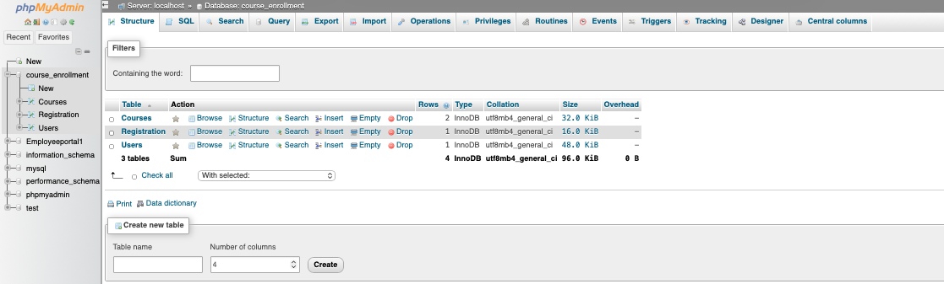Figure 1. Course enrollment database and tables.
The Courses table stores information about the courses that students can select. Its fields include the course ID, course code, course name, semester, maximum enrollment, and current enrollment. Two courses were entered for testing: CST101 Intro to Computer Technology and CST201 Web Development Fundamentals. These records provided enough information to test the registration functions without making the database unnecessarily large.
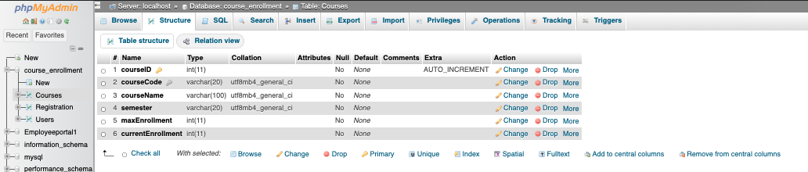Figure 2. Structure of the Courses table.
The Registration table was created to record which courses a student selects. It includes a registration ID, student ID, course ID, and semester. The student ID connects the registration to a student, while the course ID identifies the selected course. Separating student, course, and registration information makes it easier to manage changes to the system. Chen (1976) explains how database design can represent different entities and the relationships between them. This concept is reflected in the way the system separates users, courses, and registrations.
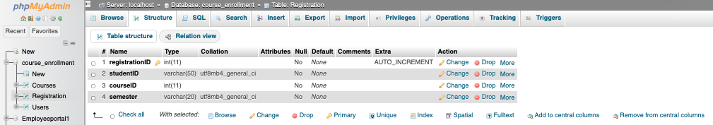Figure 3. Structure of the Registration table.
The Courses table was also populated with the information needed for the Fall 2026 semester. Viewing the table in MySQL confirmed that both test courses were stored correctly and available for the registration process.
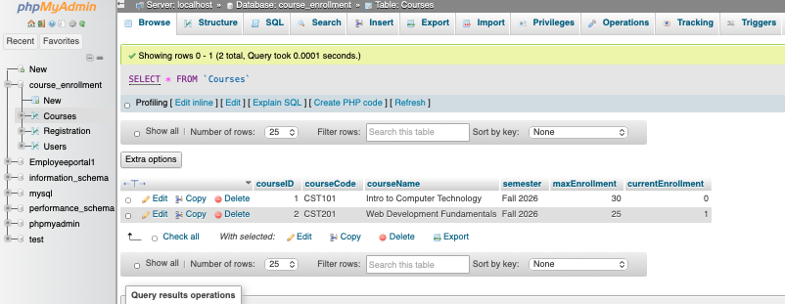Figure 4. Course records stored in the Courses table.
Course Registration
The next part of the implementation involved connecting the course pages to the MySQL database. The Available Courses page displays the courses offered for Fall 2026 and provides an option that allows the student to register. The page retrieves the course information from the database so that the information displayed to the student reflects the records stored in MySQL.
Before adding CST101, the Registration table contained only the student's registration for CST201. This provided a clear starting point for testing whether the system could successfully add another course.
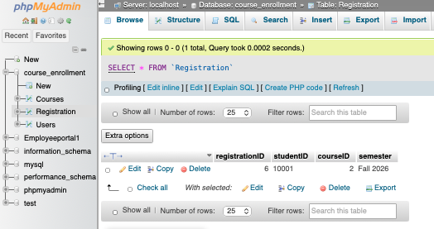
Figure 5. Registration table before adding CST101.
After the student selected the option to register for CST101, the system created another record in the Registration table. The page displayed a successful registration message and showed that CST101 had an enrollment of one out of thirty students.

Figure 6. Successful registration for CST101.
The Registration table was checked again after the operation. It contained separate records for CST101 and CST201 for student 10001. Comparing the database before and after the registration confirmed that the website successfully communicated with MySQL and stored the new registration.
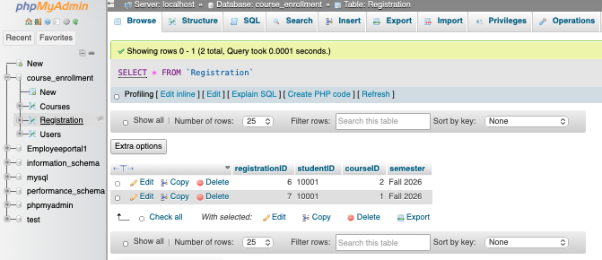Figure 7. Registration table after adding CST101.
The registration process also checks whether the student has already registered for a selected course. If the registration already exists, the system does not create another registration. This prevents the same student from accidentally registering for the same course multiple times. The enrollment displayed on the course page is based on the registrations stored in the database, which helps keep the displayed number consistent with the actual registration records.
Viewing and Removing Courses
The My Courses page was developed so that a student can view the courses currently associated with the student account. After registering for both available courses, the page displayed CST101 and CST201 along with the semester. An Add More Courses option also allows the student to return to the available courses and continue adding classes to the semester.

Figure 8. My Courses page displaying multiple registered courses.
The system also allows a student to remove a course from the schedule. Testing this function involved removing CST101 while keeping CST201 registered. After the operation, the system displayed a successful removal message, CST101 disappeared from the student's schedule, and CST201 remained.
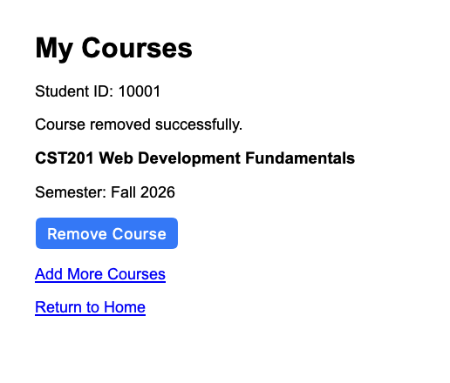
Figure 9. My Courses page after removing CST101.
The database was then checked to verify that the change was actually stored. The CST101 registration was no longer present, while the CST201 registration remained. This was important because a change displayed only on the webpage would not be enough to demonstrate that the database operation was successful.
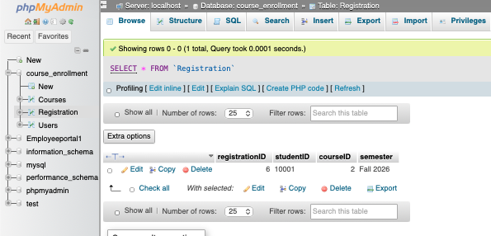Figure 10. Registration table after removing CST101.
System Implementation
The system uses PHP to connect the webpages with the MySQL database and perform the registration operations. The Available Courses page retrieves course information, checks existing registrations, adds new registrations, and determines the current number of students registered for each course. The implementation was kept focused on the requirements of the project rather than adding unnecessary features.
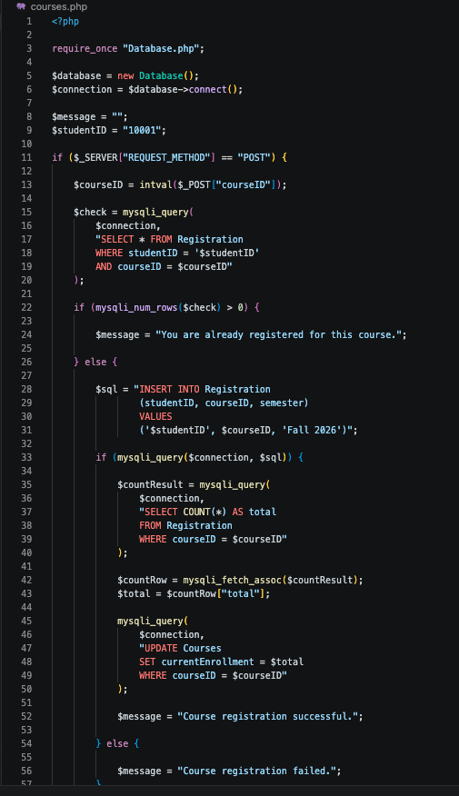
Figure 11. PHP used to process course registration.
The My Courses page retrieves the student's registered courses and processes course removals. When a course is removed, the corresponding registration is deleted from the database. The enrollment information then reflects the registrations that remain in the system.
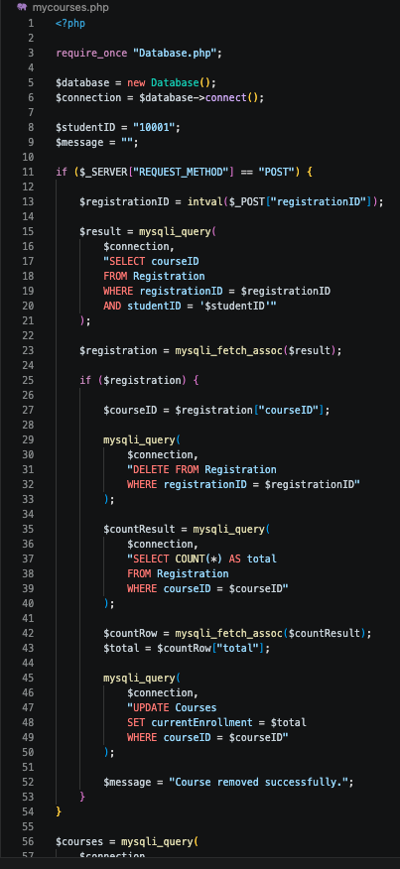
Figure 12. PHP used to process course removal.
Implementation Experience
The Week 4 implementation expanded the project from basic student account functionality into a system that can perform useful course registration tasks. One challenge during development involved keeping the displayed enrollment number consistent after a course was removed. The original approach did not always update the displayed enrollment correctly. The issue was corrected by having the system determine enrollment using the actual registration records in the database. After making this change, removing a course correctly changed its enrollment total.
Testing each function separately also helped identify problems before moving to the next requirement. Registration was tested first, followed by viewing multiple courses and then removing a course. Checking phpMyAdmin before and after these operations provided confirmation that the changes were being stored correctly. This experience demonstrated why testing both the visible webpage and the underlying database is important when developing a database driven application.
The Week 3 portion of the project also served as the starting point for this implementation. The existing registration page, database connection, student information, and navigation were kept while the new course registration features were added. This allowed the project to build on the previous work instead of creating a separate system. The additional pages were also connected through the home page so the different parts of the system could be reached from one location.
Conclusion
The Week 4 development successfully expanded the Online Course Enrollment System with database supported course registration features. The project now includes tables for users, courses, and registrations, along with pages that allow a student to view available courses, register for multiple courses, view a current schedule, add more courses, and remove courses. The before and after database tests confirmed that the website correctly changed the registration information stored in MySQL. The implementation also provided experience identifying and correcting an enrollment tracking problem during testing. These additions move the project closer to the original system requirements by connecting the website interface with working database operations.

References

Chen, P. P. (1976). The entity relationship model: Toward a unified view of data. ACM Transactions on Database Systems, 1(1), 9–36. https://doi.org/10.1145/320434.320440

Codd, E. F. (1970). A relational model of data for large shared data banks. Communications of the ACM, 13(6), 377–387. https://doi.org/10.1145/362384.362685

Tsui, F., Karam, O., & Bernal, B. (2018). Essentials of software engineering (4th ed.). Jones & Bartlett Learning.

